# *The Unpredictable Swap*

# 

***Target Platform:* Console and PC**

***Target Audience:* Teens and Adults**

***Target Rating:* 12a**

***Expected Shipping Date:* TBD**

**Story and Gameplay**

In The Unpredictable Swap, players embark on an adventurous journey in the vibrant land of Techtonia. A catastrophic event alters the lives of three key characters: Sir Rhys, the valiant tech knight turned accountant; Darius Danger, the villain now wearing the mantle of a hero; and Owen Jones, an ordinary accountant discovering his inclination towards villainy. As players navigate this topsy-turvy world, they face critical choices that shape the narrative.

Gameplay evolves across six levels:

*The Twisted Fate:* Players navigate initial decisions as characters adapt to their new lives.

*Diverging Paths:* Moral dilemmas shape evolving character narratives.

*Converging Destinies:* Characters forge alliances to face a common threat.

*The Crossroads:* Players decide between restoring order or embracing new paradigms.

*The Repercussions:* Witness consequences based on earlier choices.

*Epilogue of Diversity:* Multiple endings reflect players' actions throughout the narrative.

**Game Flow**

Players grow as challenges increase, tying into the story's progression. Experience points unlock new abilities and insights into characters' altered roles, influencing branching outcomes.

Character progression:

Sir Rhys gains insight into the value of heroism in unexpected situations.

Darius Danger grapples with moral choices and the weight of heroism.

Owen Jones balances his newfound abilities with his moral compass.

**Character(s) and Controls**

Players control Sir Rhys, Darius Danger, and Owen Jones, each with unique abilities reflecting their swapped roles. Controls include standard movement commands with special abilities mapped to specific buttons on the controller. For example:

*Sir Rhys*: Sword techniques mapped to action buttons

*Darius Danger*: Energy blasts and defensive moves

*Owen Jones*: Manipulation of dark powers and stealth abilities

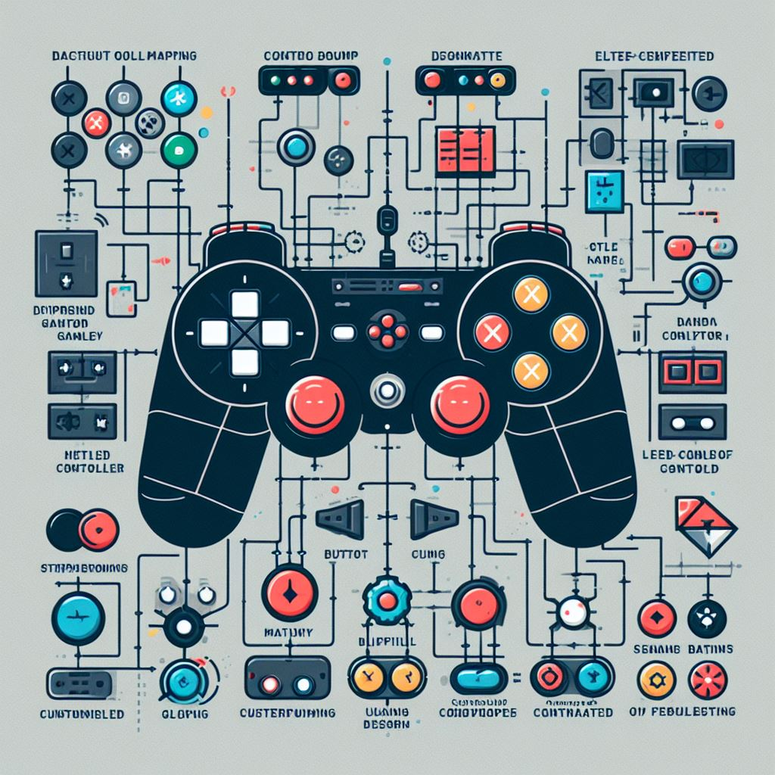

**Main Gameplay Concepts and Platform Specific Features**

The game blends adventure, puzzle-solving, and moral decision-making across levels and story chapters. It incorporates platforming elements, environmental puzzles, and combat scenarios unique to each character's abilities.

Platform-specific features capitalize on console capabilities:

Dual-screen mechanics for strategic decision-making

Utilization of haptic feedback for immersive combat experiences

**Game World**

Players explore various environments in Techtonia:

Cityscapes where mundane meets the extraordinary

Mystical forests hiding secrets and puzzles

Technological dungeons reflecting the characters' struggles

The world design encourages nonlinear exploration, connecting diverse environments in a hub-style navigation system.

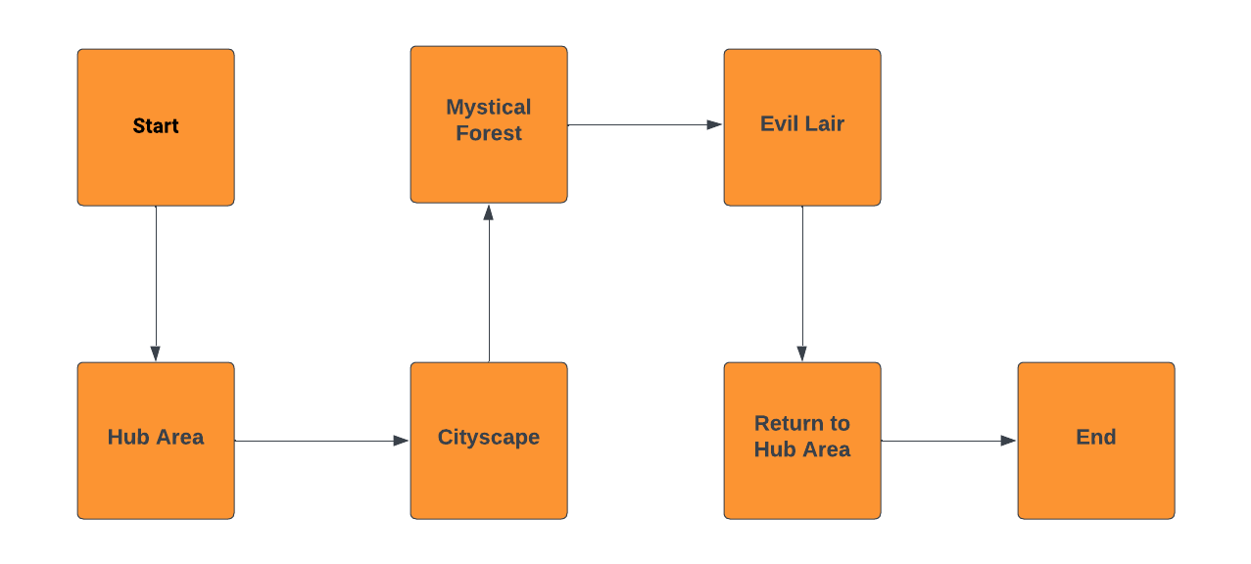

**Interface**

The interface evokes a juxtaposition of mundane and heroic elements, reflecting characters' internal conflicts. The mood transitions based on the character's story progression, supported by an adaptive soundtrack.

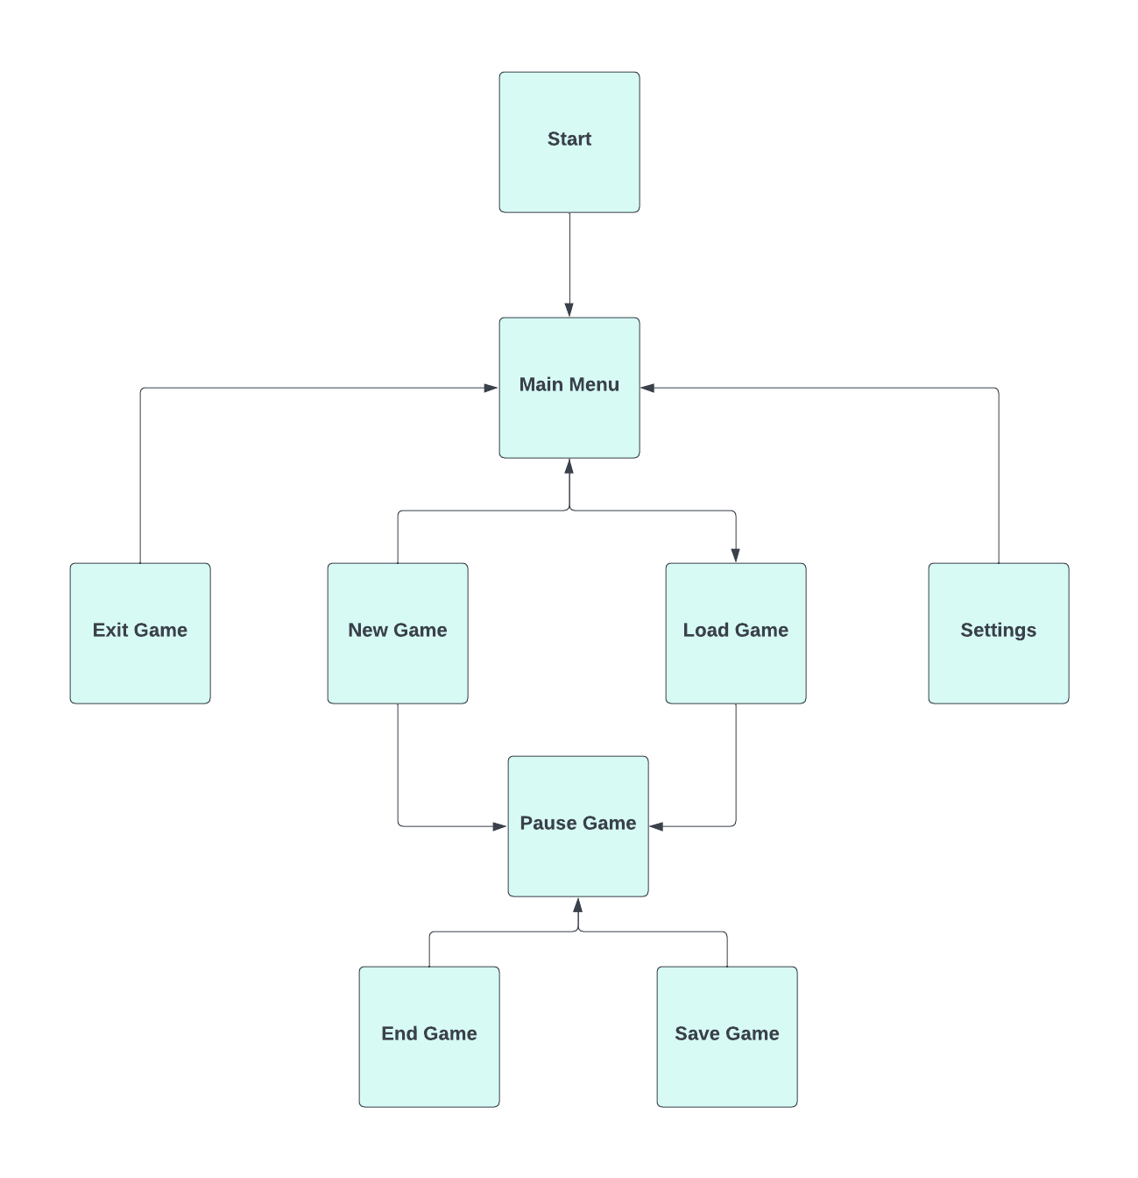

**Mechanics and Power-ups**

Unique mechanics include:

Environmental puzzles requiring character-specific abilities

Moral decision-making affecting character development

Dynamic combat system adaptable to each character's style

Power-ups and collectibles grant enhancements, unlock abilities, and provide insights into character growth. They can be used to influence narrative branches and aid in overcoming challenges.

**Enemies and Bosses**

Enemies exhibit diverse abilities and tactics:

Technological minions testing combat skills

Moral dilemmas embodied in villainous adversaries

Environmental hazards challenging puzzle-solving capabilities

Bosses present unique challenges tied to character growth. Overcoming them unlocks new abilities and insights into the story.

*Bosses* include

* *Darius Danger*
* *Owen Jones*

*Enemies* include

* *Goblins*
* *Aliens*

**Cutscenes, Bonus Material, and Comps**

*Cutscenes present pivotal moments between levels and reflect various animation styles. Bonus materials unlock additional character insights, alternative storylines, and concept art upon completion. The cutscenes will be made using CGI.*

*The competition upon market release includes games that blend adventure, moral choices, and character-driven narratives.*

***Contact Information:***

**Pickwick Games, Dublin, Ireland**

**Contact Email** [**pwgames@gmail.com**](mailto:pwgames@gmail.com)

**Contact No. 087675868**